Draft paper From Signal To Image using CNN

Ref:

<https://ataspinar.com/2018/12/21/a-guide-for-using-the-wavelet-transform-in-machine-learning/>

<https://github.com/taspinar/siml>

Example of Signal I = 1, label 1

The scalogram

I = 1000, label 2

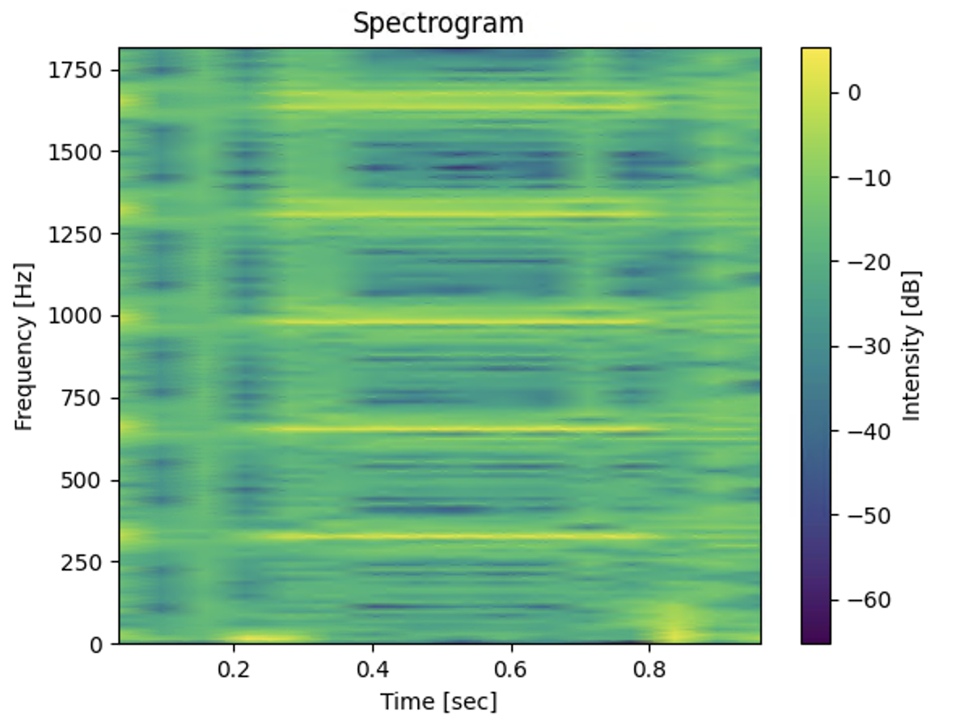

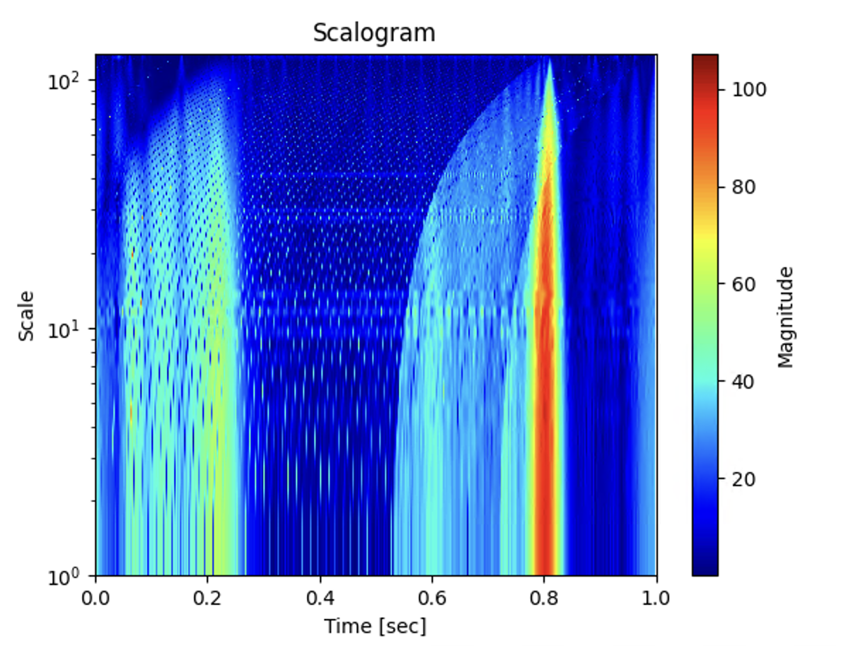

From these two images: it look like different but we do not know the imapact

Results of Experiment:

SVM

PCA -30

ListOA: [0.75316074653823, 0.748195669607057, 0.7443910256410257, 0.7422586520947176, 0.746011486917677, 0.7593486127864898, 0.7457932692307693, 0.752007136485281, 0.7382903981264637, 0.7465277777777778]

ListAA: [0.7402073620469288, 0.7355506492506344, 0.7309123621558511, 0.7252875362331803, 0.7342352821094694, 0.751141038539712, 0.7358187184613919, 0.7362291380504443, 0.732922744708235, 0.7336959336959338]

ListKappa: [0.6046939151038955, 0.5957647792418022, 0.5926938789290657, 0.5899654801114771, 0.5958825332295716, 0.6123482819300139, 0.5917282085905797, 0.6039070642365083, 0.5802560765821709, 0.5974192436531274]

ListEach_Accuracy: [array([0.78850575, 0.7486631 , 0.68345324]), array([0.7754491 , 0.76689189, 0.66431095]), array([0.78090767, 0.73856209, 0.67326733]), array([0.78738739, 0.70915033, 0.67932489]), array([0.77833126, 0.70663265, 0.71774194]), array([0.7826087 , 0.78531073, 0.68550369]), array([0.76888889, 0.75733333, 0.68123393]), array([0.79117148, 0.71863118, 0.69888476]), array([0.75135722, 0.73796791, 0.7094431 ]), array([0.78290598, 0.70707071, 0.71111111])]

List F-mean: [0.7300345767745663, 0.7220577579286837, 0.7240443343864151, 0.7190288966926026, 0.72686089589281, 0.7348147631290988, 0.7200295965030937, 0.7267390259324356, 0.7169792018012869, 0.7277392978127103]

List F-1: [array([0.82204913, 0.69825436, 0.66980024]), array([0.8202692 , 0.71608833, 0.62981575]), array([0.80679062, 0.70514821, 0.66019417]), array([0.80851064, 0.72333333, 0.62524272]), array([0.80697224, 0.71025641, 0.66335404]), array([0.82929711, 0.71557272, 0.65957447]), array([0.81893491, 0.69950739, 0.64164649]), array([0.83214286, 0.71186441, 0.63620981]), array([0.80138969, 0.69259724, 0.65695067]), array([0.80776014, 0.72790295, 0.64755481])]

Random Forest:

rf_classifier = RandomForestClassifier(n_estimators=100, random_state=42)

ListOA: [0.8524984948826009, 0.8572574178027266, 0.8573717948717948, 0.8342440801457195, 0.8666241225271218, 0.8576598311218335, 0.8617788461538461, 0.8626226583407671, 0.8618266978922716, 0.8550347222222222]

ListAA: [0.8588030100632129, 0.8591484039840398, 0.8586546987572355, 0.8245787454353687, 0.8649704746195974, 0.8621472798695372, 0.8694189701697829, 0.8594504325472815, 0.8690112433862435, 0.850883097112491]

ListKappa: [0.7629050676423635, 0.7717833748538727, 0.7719553445399717, 0.7364002828108017, 0.7878294929203723, 0.7714728915785791, 0.7791837785006515, 0.781300990159216, 0.7791288948115938, 0.7687922959608596]

ListEach_Accuracy: [array([0.84441939, 0.90804598, 0.82394366]), array([0.8597561 , 0.91143911, 0.80625 ]), array([0.86064319, 0.9047619 , 0.81055901]), array([0.86151079, 0.82783883, 0.78438662]), array([0.87218045, 0.87087912, 0.85185185]), array([0.85471056, 0.91761364, 0.81411765]), array([0.85697941, 0.94186047, 0.80941704]), array([0.87609075, 0.87951807, 0.82274247]), array([0.85222222, 0.92222222, 0.83258929]), array([0.86599665, 0.82795699, 0.85869565])]

List F-mean: [0.8397351783800837, 0.8422415429686367, 0.8434824876885513, 0.8180187823662207, 0.8560095106692566, 0.8441688377934939, 0.8492043115149462, 0.8496287263632314, 0.8506487650781415, 0.8400211584712641]

List F-1: [array([0.88849348, 0.81443299, 0.81627907]), array([0.90167866, 0.81116585, 0.81388013]), array([0.89848122, 0.8125 , 0.81946625]), array([0.88539741, 0.79717813, 0.7714808 ]), array([0.9015544 , 0.84308511, 0.82338902]), array([0.8980322 , 0.83354839, 0.80092593]), array([0.90024038, 0.82970551, 0.81766704]), array([0.90942029, 0.84719536, 0.79227053]), array([0.89917937, 0.84802043, 0.80474649]), array([0.90226876, 0.82647585, 0.79131886])]

Using kNN

ListOA: [0.7561709813365443, 0.7610264635124299, 0.7403846153846154, 0.738615664845173, 0.7428206764518187, 0.7539203860072377, 0.7457932692307693, 0.7591436217662801, 0.7207259953161592, 0.7699652777777778]

ListAA: [0.7530628943766094, 0.7628492866257693, 0.7312249274553952, 0.723055209207626, 0.732905859187137, 0.7553957108116963, 0.7411959385643595, 0.7479640682803251, 0.7118157260702027, 0.7633599508599508]

ListKappa: [0.6076668569898876, 0.6163045229077784, 0.5857864026748836, 0.5855350378787879, 0.5907465445194471, 0.6025233034215955, 0.5932273914083711, 0.6162754875001426, 0.5537240604123164, 0.6339322544439435]

ListEach_Accuracy: [array([0.76569507, 0.77222222, 0.72127139]), array([0.76453055, 0.83146067, 0.69255663]), array([0.76552795, 0.74410774, 0.68403909]), array([0.7853211 , 0.69836066, 0.68548387]), array([0.7699005 , 0.7106599 , 0.71815718]), array([0.75494505, 0.81073446, 0.70050761]), array([0.76190476, 0.77747253, 0.68421053]), array([0.78793103, 0.71320755, 0.74275362]), array([0.74225664, 0.70050761, 0.69268293]), array([0.78885135, 0.73986486, 0.76136364])]

List F-mean: [0.7377570547723015, 0.7437697442228616, 0.7228296945076544, 0.7189420586982841, 0.7252233632293054, 0.7355988454336352, 0.7264834427460093, 0.739164747700808, 0.6997860171599317, 0.7546116732054249]

List F-1: [array([0.80780603, 0.70558376, 0.69988138]), array([0.81042654, 0.7338843 , 0.68699839]), array([0.79388084, 0.69936709, 0.67524116]), array([0.79925303, 0.71118531, 0.64638783]), array([0.79870968, 0.71611253, 0.66084788]), array([0.80539273, 0.73873874, 0.66266507]), array([0.80382775, 0.70661673, 0.66900585]), array([0.82268227, 0.70919325, 0.68561873]), array([0.78479532, 0.67564259, 0.63892013]), array([0.81858019, 0.76041667, 0.68483816])]

Result with CNN 1, no preprocessing, wavelet scale 1,128

ListOA: [0.6857314870559904, 0.6800320769847634, 0.6770833333333334, 0.6839708561020036, 0.6751754945756222, 0.6688781664656213, 0.6826923076923077, 0.6601248884924175, 0.6697892271662763, 0.7083333333333334]

ListAA: [0.6656065786240438, 0.6506304307766454, 0.6655273303461517, 0.6582863365800089, 0.649731855290396, 0.6423703998589089, 0.6707011980267795, 0.6452696745988642, 0.6505614855680819, 0.6948225194763954]

ListKappa: [0.5105166086033123, 0.49059779531686565, 0.49480941747953144, 0.5041773377475169, 0.49069318083133684, 0.4713701057385232, 0.4924625437874909, 0.4798067823487929, 0.4881624767675522, 0.5310133921052855]

ListEach_Accuracy: [array([0.79268293, 0.6509009 , 0.55323591]), array([0.75474684, 0.61842105, 0.5787234 ]), array([0.76429809, 0.6967509 , 0.53553299]), array([0.78557505, 0.63945578, 0.54982818]), array([0.77266576, 0.58719647, 0.58933333]), array([0.73745624, 0.60807601, 0.58157895]), array([0.72954545, 0.73255814, 0.55 ]), array([0.81497797, 0.51466667, 0.60616438]), array([0.78100264, 0.55818182, 0.6125 ]), array([0.74193548, 0.69547325, 0.64705882])]

List F-mean: [0.6681903440723445, 0.6425161595620196, 0.6588539218399534, 0.65919728333785, 0.6495445111957358, 0.6369959690677729, 0.6553567312805321, 0.6427091029313406, 0.6485076414683806, 0.6814600184437948]

List F-1: [array([0.76122316, 0.66284404, 0.58050383]), array([0.77750611, 0.6545961 , 0.49544627]), array([0.7506383 , 0.63071895, 0.59520451]), array([0.77574591, 0.63945578, 0.56239016]), array([0.76902357, 0.63258026, 0.5470297 ]), array([0.7646703 , 0.60663507, 0.53968254]), array([0.76886228, 0.6453265 , 0.55188141]), array([0.75126904, 0.60031104, 0.57654723]), array([0.75703325, 0.63103803, 0.55745165]), array([0.78699743, 0.64627151, 0.61111111])]

Ensamble 1

ListOA: [0.8001204093919325, 0.7923015236567763, 0.7836538461538461, 0.7750455373406193, 0.7798340778557754, 0.7973462002412546, 0.7824519230769231, 0.7832292595896521, 0.775175644028103, 0.7821180555555556]

ListAA: [0.7929013284656728, 0.7868374185016697, 0.7764495188005123, 0.7587331385324276, 0.7696223905835091, 0.7902121378774728, 0.7773531738065417, 0.7686174802835718, 0.7710802099024544, 0.768545395289474]

ListKappa: [0.6802439055503819, 0.6676227171593054, 0.6541850627159034, 0.6424838910390939, 0.6508006945036546, 0.6747588516422376, 0.6522419863903006, 0.6555196550176096, 0.6406641559383619, 0.6541376406644721]

ListEach_Accuracy: [array([0.82080925, 0.80789474, 0.75 ]), array([0.80517504, 0.82154882, 0.7337884 ]), array([0.80153846, 0.79470199, 0.73310811]), array([0.82065217, 0.73770492, 0.71784232]), array([0.81115336, 0.72704715, 0.77066667]), array([0.81818182, 0.82384824, 0.72860636]), array([0.7981756 , 0.80376344, 0.73012048]), array([0.82342657, 0.73062731, 0.75179856]), array([0.78713969, 0.78191489, 0.74418605]), array([0.82130584, 0.73972603, 0.74460432])]

List F-mean: [0.7824613405910726, 0.7739846124221024, 0.7662596817232075, 0.7527880074982388, 0.7633523810013075, 0.7765651668362525, 0.7634279390748707, 0.7617983319045356, 0.7571240133122084, 0.7631221138593908]

List F-1: [array([0.85336538, 0.75990099, 0.73411765]), array([0.84504792, 0.76850394, 0.70840198]), array([0.8349359 , 0.75353218, 0.71031097]), array([0.84044527, 0.75125209, 0.66666667]), array([0.83387622, 0.74083439, 0.71534653]), array([0.85918854, 0.76767677, 0.70283019]), array([0.83983203, 0.73918418, 0.71126761]), array([0.85403445, 0.73469388, 0.69666667]), array([0.83138173, 0.7359199 , 0.70407041]), array([0.84526967, 0.75524476, 0.68885191])]

Ensamble 2

ListOA: [0.6243226971703792, 0.6471531676022454, 0.6434294871794872, 0.6493624772313297, 0.635609444798979, 0.6429433051869723, 0.6280048076923077, 0.6021409455842998, 0.6065573770491803, 0.6423611111111112]

ListAA: [0.6527432201931052, 0.6548493171160062, 0.6056332225734122, 0.6498787271433343, 0.6599738347118714, 0.7029053092216063, 0.6043470794574978, 0.6194799311407085, 0.6591171741581168, 0.6246062896962675]

ListKappa: [0.3451465873781071, 0.3857197875522834, 0.38301696881089453, 0.39841695413094713, 0.3821297935062504, 0.3745090729500231, 0.35171374641323894, 0.317245636220124, 0.3250492639660624, 0.39255903244384727]

ListEach_Accuracy: [array([0.5905826 , 0.75 , 0.61764706]), array([0.60489883, 0.81203008, 0.54761905]), array([0.61597374, 0.775 , 0.42592593]), array([0.62082262, 0.72881356, 0.6 ]), array([0.6122633 , 0.69458128, 0.67307692]), array([0.5971897 , 0.80882353, 0.7027027 ]), array([0.58768511, 0.79202279, 0.43333333]), array([0.57126031, 0.70384615, 0.58333333]), array([0.57564003, 0.70171149, 0.7 ]), array([0.61064087, 0.73376623, 0.52941176])]

List F-mean: [0.5175469135478877, 0.5283309530769176, 0.52502043274401, 0.5232861269294823, 0.5289109415082417, 0.52224062514627, 0.49623547244489724, 0.47933217885704216, 0.47562897498720086, 0.5185534291235874]

List F-1: [array([0.72124756, 0.6640625 , 0.16733068]), array([0.74054759, 0.71523179, 0.12921348]), array([0.74470899, 0.70569106, 0.12466125]), array([0.74079755, 0.73005093, 0.0990099 ]), array([0.73207547, 0.71032746, 0.1443299 ]), array([0.73663938, 0.72083879, 0.1092437 ]), array([0.72744814, 0.70558376, 0.05567452]), array([0.70289855, 0.69318182, 0.04191617]), array([0.70835322, 0.68990385, 0.02862986]), array([0.73401163, 0.76870748, 0.05294118])]

<https://github.com/Yu-Group/iterative-Random-Forest/blob/master/demo/28_iRF_demo_sklearn.ipynb>

learn iterative random forest and make the paper

iRF

OA: 0.8546887896961713

AA: 0.8555771012946423

Kappa: 0.7677422648275529

Each_Accuracy: [0.85738038 0.88506011 0.82429081]

ListOA: [0.8537025888019265, 0.8556535685645549, 0.8501602564102564, 0.8387978142076503, 0.8596043395022336, 0.8588661037394452, 0.8581730769230769, 0.8617305976806423, 0.8612412177985949, 0.8489583333333334]

ListAA: [0.8574958644634963, 0.8578832065650627, 0.851859698904951, 0.8301525873507298, 0.8590766860049553, 0.8595311700104314, 0.8685378597284817, 0.8576530776197494, 0.8684230267453973, 0.8451578355531684]

ListKappa: [0.7650494264529026, 0.7686330009782023, 0.7604299154643303, 0.743311566868482, 0.7760139924657953, 0.7739105402004999, 0.7730998679751666, 0.779882818685669, 0.7779998288914579, 0.7590916902930229]

ListEach_Accuracy: [array([0.84937712, 0.89972145, 0.82338902]), array([0.85240964, 0.89285714, 0.82838284]), array([0.85298622, 0.90073529, 0.80185759]), array([0.8625 , 0.82720588, 0.80075188]), array([0.86100861, 0.85907859, 0.85714286]), array([0.86222732, 0.90163934, 0.81472684]), array([0.84790011, 0.94690265, 0.81081081]), array([0.87456446, 0.86166008, 0.83673469]), array([0.85176991, 0.91830986, 0.83518931]), array([0.8590604 , 0.84249084, 0.83392226])]

List F-mean: [0.8405146132110367, 0.8406006806469425, 0.8365495333441854, 0.822548000419542, 0.8474580080608137, 0.8450653719287091, 0.8462160376771637, 0.8480502636876127, 0.8489402409958747, 0.8350091444467457]

List F-1: [array([0.89179548, 0.82083863, 0.80890973]), array([0.89912629, 0.80906149, 0.81361426]), array([0.89048761, 0.80724876, 0.81191223]), array([0.88950276, 0.795053 , 0.78308824]), array([0.89801155, 0.83751651, 0.80684597]), array([0.9010198 , 0.8365019 , 0.79767442]), array([0.8940754 , 0.82731959, 0.81725312]), array([0.90859729, 0.83685221, 0.7987013 ]), array([0.9005848 , 0.83804627, 0.80818966]), array([0.89432314, 0.8318264 , 0.77887789])]

good paper about adaptive wavelet